CS483 Project 2 – Clustering Analysis, Motion and Face Capture.

CS483 – Topics in Computer Science, Machine Learning

Project performed by: Joshua Sweet and Henry Unruh

Introduction

The purpose of this project was to implement some clustering algorithms as well as to implement machine learning techniques to detect motion and faces in photos.

Problem 1

The first problem was to implement a clustering algorithm to a set of data. The data that was used is in a .CSV file provided in the .ZIP archive. It is a dataset based on income and spending. Our group used K-Means clustering, as it was the first and memorable method that came to us. The final results are embedded below.

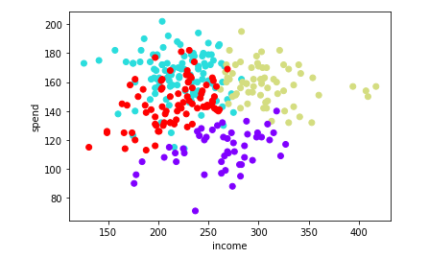

This scatterplot indicates four different groups of entities – one set that has moderate income, but doesn’t spend all too much (purple), one set that generally lacks income, but spends a lot (red), another set that spends way above their income (blue/teal), and the last set that has a large amount of income, and does a moderate amount of spending (pale green).

Problem 2

The second problem was to create three different moon sets with three different clustering methods: KMeans, Hierarchal clustering, and DBSCAN. The resulting image is attached below:

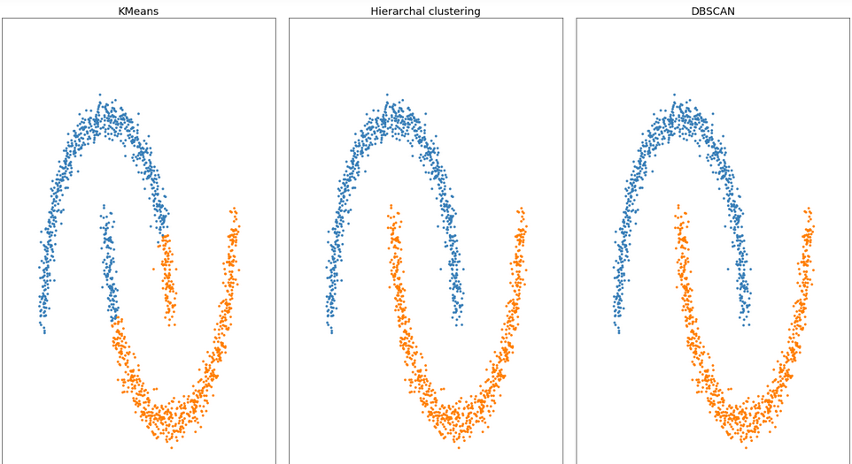

Problem 3

The code that we had to design was a program that utilizes a webcam to detect motion. A picture of the result is embedded below.

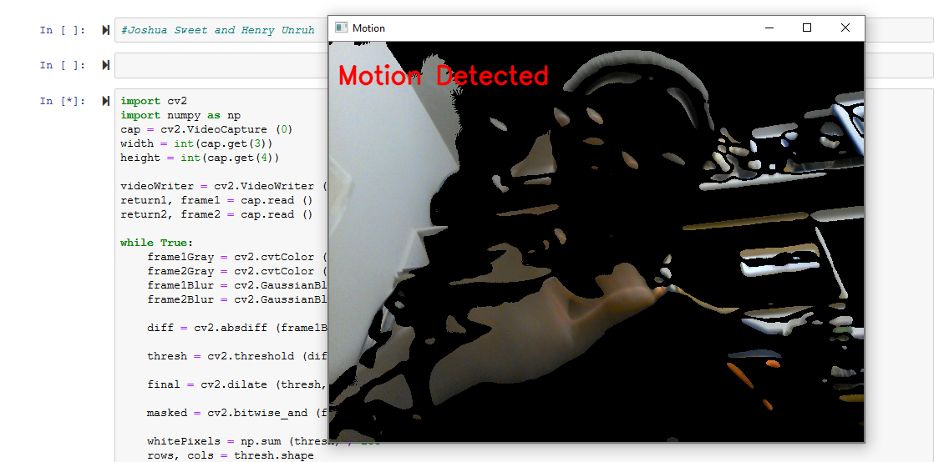

This program produces a low-quality video. It is completely black when no motion is detected, but will change when motion is detected.

Problem 4

The final problem was to create a program that detects multiple faces given an image. The final result of the program is embedded below:

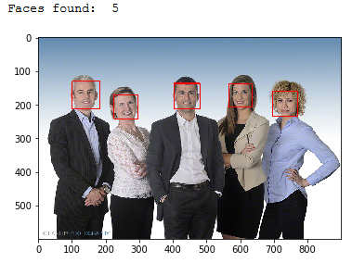

This program detects 5 faces.